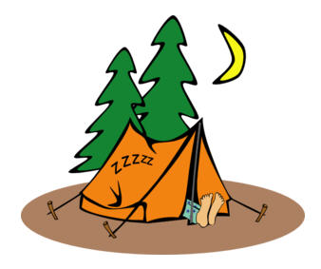 NFC Camp Card Settlement Form 2026

District: _____________________________________ Unit Type/Number: __________

Name (Please Print): ______________________________________________________

Best Phone Number: ______________________________________________________

Email Address: ___________________________________________________________

Cards For _________________________ (Name of Cards, i.e. Clay County or CC)

Total Cards ISSUED: __________
-
Total Cards RETURNED: __________
=
Total Cards SOLD: __________

AMOUNT DUE To Council (Total Cards SOLD) x $5 = __________

Signature: ______________________________ Date: ___________

